DIV

DIV Diving Engineering Co., Ltd

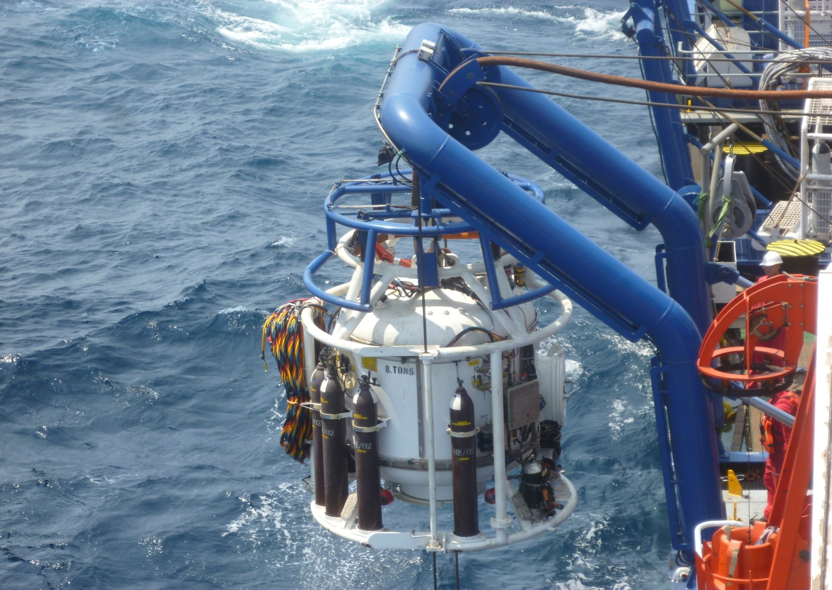

SAT8 180msw/9 man
Saturation Diving System

Specifications DIV

DIV Diving Engineering Co., Ltd

SAT8 180msw/9 man Saturation Diving System

MAIN PARTICULARS

Year built 2014
Builder FDI
Class Society ABS(tank age)
Testing/Certification IMCA D018/D024
Standard

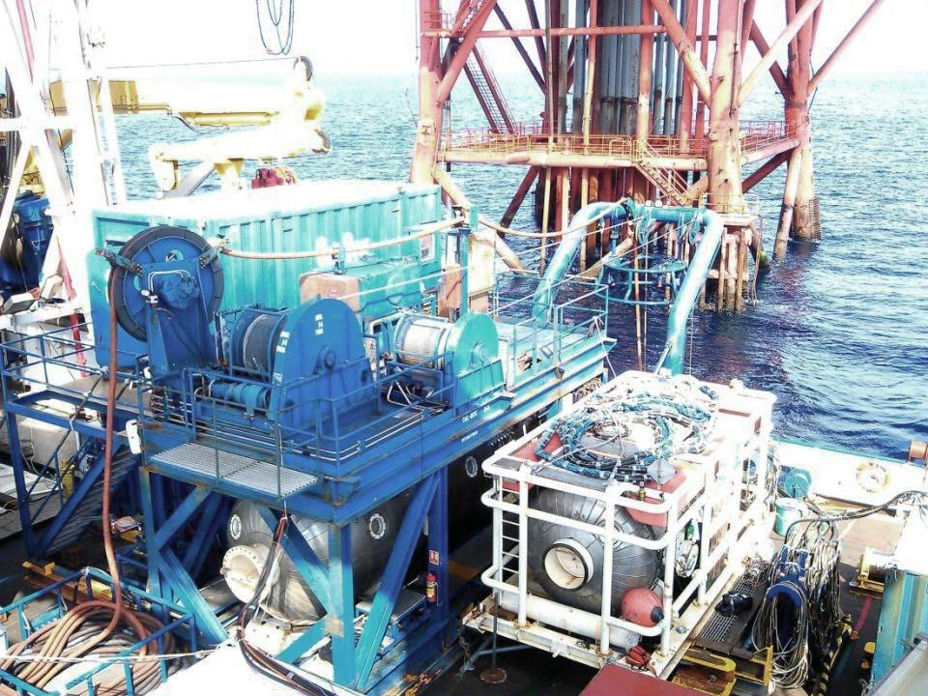

COMPONENTS

Weight Dimensions (L*W*H)
Main Module with Diving Bell 68t 12192*1962*6400
Saturation Control Van 7.5t 3048*3048*7010
HRC 15t 3048*42672
HRC Control Van 3t 3048*2438*2590
Main Umbilical Basket 3t 2438*2438*1371
Emergency Umbilical 1t 1000*1000*2000
Stores/Workshop Container 7t 6096*2438*2438
Machinery Van 10t 3048*3048*7010

SERVICES REQUIRED

Electric Power - System 440V, 60HZ
Electric Power – Hot water machine 440V, 60HZ
Emergency generator 250kVA 440V,60HZ
Compressed Air 400cfm,90psi
Seawater 25gpm
Fresh Water 5gpm

LIVING ACCOMMODATION CHAMBERS

Main Living Chamber 6 man
HRC M/Lock（9.943m³） 3 man

DIVING BELL

Capacity men 3
Diver Lockout Capability 2
Diver Hat Mounted Camera Systems 2
Volume 4.5 m³
Mating to DDC Side
Buoyancy Negative

RECLAIM SYSTEM

Type Dive x Gasmizer System
Pumps Haskel
Bell Capacity 2 Diver Reclaim
Dive Control System Divex

HYPE RBARIC EVACUATION SYSTEM

Type Side-off/Float-off HRC
Launch System Crane/winch deployment
Propulsion Tow only
Capacity men 9
Control Van Dedicated w/umbilical

UMBILICAL

Main Bell FDR 25m
Emergency Bell FDI built 180m
Lockout Diver1 60m
Lockout Diver2 60m
Bell men 65m

LIFE SUPPORT MACHINERY

Diver Hot water Unit FDI Built
CUM Units UTS
Scrubbers Dive

Specifications DIV

DIV Diving Engineering Co., Ltd

HAI YANG SHI YOU 286

GENERAL DESCRIPTION

Type MP Subsea Construction Vessel
Design SDARI
Accommodation 150 persons
Call Sign BFBF6
IMO No 9662239
Flag China

Classification(DNV)

DNV+1A1,ICE-E,SPS,DPS3,CRANE,HELDK,BIS,COAT-PSPC(B),CLEAN,E0,NAUT-OSV(A),DK(+),COMF-V(3)C(3)CSA,Special Purpose Ship(2008),Ice Class B,DP-3,Lifting
Appliance, Helicopter Facilities, PSPC
(B),In Water Survey
CSM,AUT-0,OMBO,Clean,COMF
(NOISE3),COMF(VIB3)

Main Dimensions

Overall length 140.75m
Length between p.p 127.85m
Breadth molded 29.0m
Depth main deck 12.8m
Draft(max) 8.5m

Deck Equipment

2×Windlass/Mooring winches fwd.-MEP
2×Mooring winches aft- MEP
2×Provision cranes

Deck Space

Deck Material Steel/wood
Moon pool 7.2×7.2m
Main Deck Area 1900/㎡

DP System

DPIII A redundant Dynamic Positioning
(DP)system

NAV/Com

1×MF/HF SSB Simplex radio Telephony Station 150W
2×EPIRB Cospas/Sarsat free-float beacon
2×Radar transponders for life-raft/boat(9GHZ)
3×Portable waterproof VHF radios
Satellite communication, mobile telephones/fax
VHF/UHF and mobile telephones/fax/ VHF/UHF
Internal communication systems
1×complete PA system and 1×telephone system to be installed
Infrastructure/LAN

Power & Propulsion

Main 6 sets,4×3884kW+2×2904kW
Em.Gen 1×500 kW

Accommodation

150 persons
28 Single Cabin/39 Double Cabins/11 cabins with 4 beds
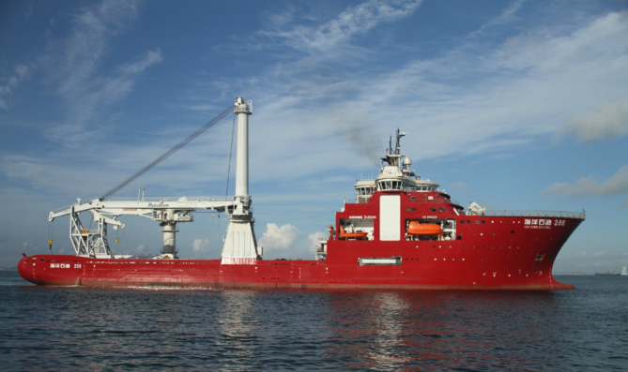

Thruster

Stern 2×azimuth thrusters Max.Continuous
Rating abt.4500kW each
Bow 2×tunnel thrusters forward. Rating
Abt. 2200kW
1×Retractable azimuth thruster
Rating 2200kW

Rescue

Life boat
2×fiberglass reinforce plastic, totally enclosed type lifeboats
1×life boat on each side, with capacity of 50%(75persons)
2×Fast Rescue Craft/Man Over Board Boat
2×davit launched type inflatable life rafts, with capacity of 20 persons

Helicopter Deck

Diameter deck 22.2m
Max. take-off-mass 12.8t
Aircraft type Sikorsky S-92,
S-61 and Euro Copter EC225 Super Puma MKII

Tank Capacities

Marine Gas oil/diesel oil, abt. 2800 m³
Potable water, abt. 750 m³
Water ballast, abt. 7300 m³
Rig chain lockers abt. 1000 m³

Crane

Master Type Crane
SWL(2 falls)@ 16.5m 400Te
SWL(1 falls)@ 31.5m 200Te
Dynamic factor 1.1
Working Range
Single line 7.8-37.0m
2 falls 8.8-39.5m
Storage Capacity
Hook travel, single line 3000m
Main Hoist Wire Rope
Wire rope diameter 92mm
Wire rope MBL 650 Te

Specifications DIV

DIV Diving Engineering Co., Ltd

ROV

Schilling UHD78/79 ROV

Vehicle
HPU 200Hp system,149kW
Depth rating 3000m
Vehicle dimensions
Length 3000mm×Width 1900mm×Height 2000mm
Speed Fwd/Aft 3.2knots
Lateral 3.2 knots
Vertical 2.5 knots
Bollard pull Forward/Aft,1200 Kg
Lateral,1200Kg
Vertical,1000Kg
Payload 300Kg
Manipulators 7 function Schilling Titan 4
5 function Schilling Rigmaster

Auto function
Auto Heading/Depth/Altitude/Roll/Pitch
Stationkeep(DP)
Camera (5)Kongsberg
(1 HD color camera fiber output)
(1)TITAN 4 Wrist camera
Lights (12)Variable 120VAC/250W
Pan & Tilt 2 Electric Pan & Tilt Unit
Valve Pack (2)8-function
TMS Schilling XE™ 900m tether Capacity,with 850m tether
LARS Active Heave Compensated

